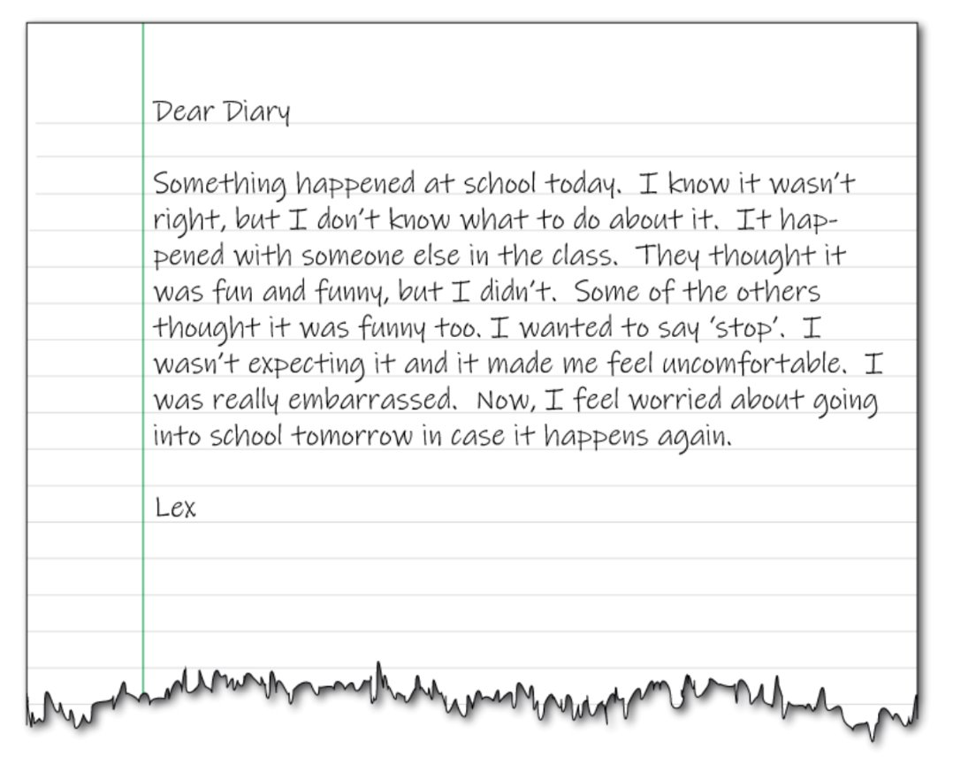
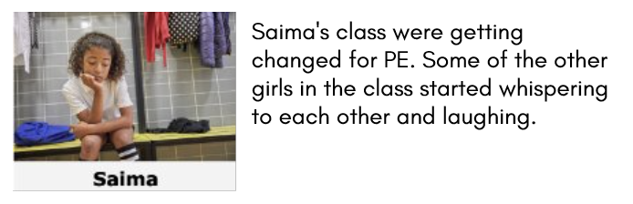

How do y ou think Salma is feeling?
What do you think Salma might be thinking?
What should Salma do next?

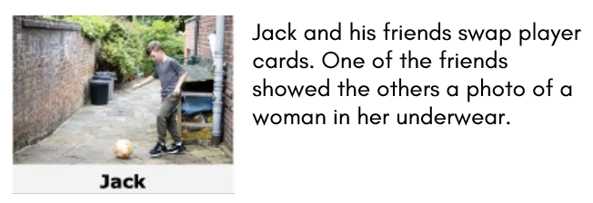
How do y ou think Jack is feeling?
What do you think Jack might be thinking?
What should Jack do next?

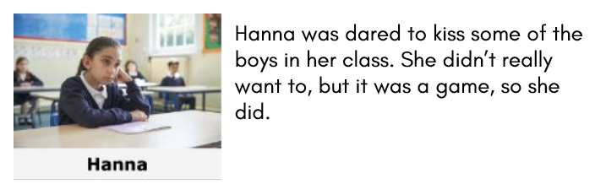

How do y ou think Hanna is feeling?
What do you think Hanna might be thinking?
What should Hanna do next?

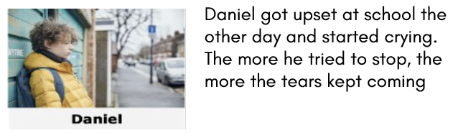
How do y ou think Daniel is feeling?
What do you think Daniel might be thinking?
What should Daniel do next?

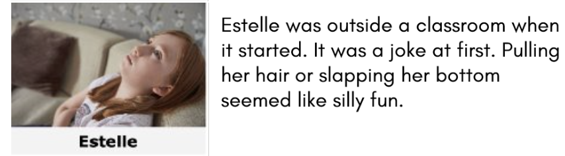

How do y ou think Estelle is feeling?
What do you think Estelle might be thinking?
What should Estelle do next?

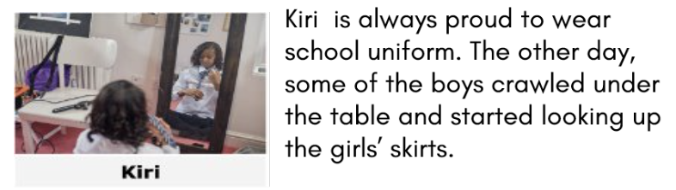

How do y ou think Kiri is feeling?
What do you think Kiri might be thinking?
What should Kiri do next?

